
Name:
Teacher:
YEAR 11 SEMESTER ONE 2005

HUMAN BIOLOGY EXAMINATION

SECTION B

TIME ALLOWED FOR THIS PAPER

Reading Time: 10 minutes
Working Time: 150 minutes

Section A: Multiple Choice – 40 Questions – 40%
Answer the multiple choice questions by CROSSING out the letter of your choice on the answer sheet provided.

Section B: Short Answers – 5 Questions – 40%
Answer the questions in the spaces provided. Answers are to be in BLUE or BLACK biro.

Section C: Extended Answers – 2 Questions – 20%
Write the answer on the lined paper provided.
Section A = / 40

Section B = / 114 X 0.35 = /40

Section C = /20
SECTION B: - Short Answer

You must answer all the questions in Section B in the spaces provided. Answers must be in BLUE or BLACK PEN, diagrams are to be in pencil and clearly labelled.

Question 41

(a) Describe how the following factors affect the rate of diffusion?

Concentration of Molecules
_________________________________________________________________________
_________________________________________________________________________
_________________________________________________________________________
_________________________________________________________________________
Temperature
_________________________________________________________________________
_________________________________________________________________________
_________________________________________________________________________
_________________________________________________________________________
(2)

(b) What are the differences between aerobic and anaerobic respiration?
Aerobic Respiration _________________________________________________________________________
_________________________________________________________________________
_________________________________________________________________________
_________________________________________________________________________
_________________________________________________________________________

Anaerobic Respiration
_________________________________________________________________________
_________________________________________________________________________
_________________________________________________________________________
_________________________________________________________________________
_________________________________________________________________________
(2)

- Identify the organelles labelled from the following diagrams and write a major function for each of them below. (5)

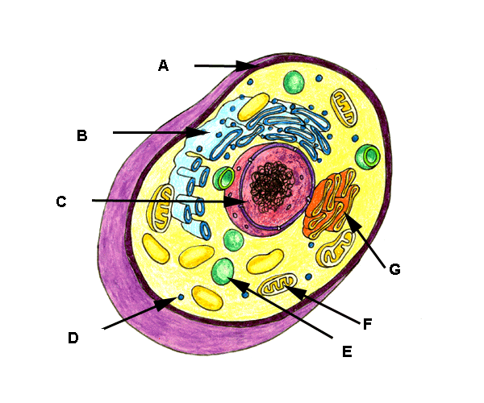

 | STRUCTURE | FUNCTION
A
B
C
F
G

(d) Complete this equation. (2)

C₆ H₁₂O₆ + ___________________ → 6CO₂ + 6H₂0 + _____________

(e) Which type of respiration is represented by this equation? (1)
_________________________________________________________________________

(f) In which part of the cell does the equation in (f) take place? (1)

_________________________________________________________________________

(g) Give one use for the ATP. (1)
___________________________________________________________________________

___________________________________________________________________________

(h) For each of the processes below. State which organelles or structures are associated with that process.

Secretion
Cellular Respiration
Pinocytosis
Phagocytosis
Protein Synthesis
Cell Division

(6)

Question 42.
- Label the diagram of the skeleton in the table provided. (5)
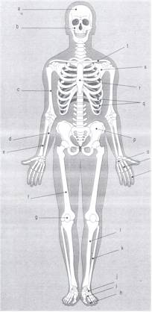

a
b
d
f
g
k
q
r
s
t

Question 43.
(a) Explain the functions of the following structures.
Aorta
______________________________________________________________________________________________________________________________________________________

Semi Lunar Valves
______________________________________________________________________________________________________________________________________________________

Pulmonary Artery
______________________________________________________________________________________________________________________________________________________
(3)

(b) On these smaller diagrams, show the passage through the heart of oxygenated blood on diagram A and deoxygenated blood on Diagram B. (4)

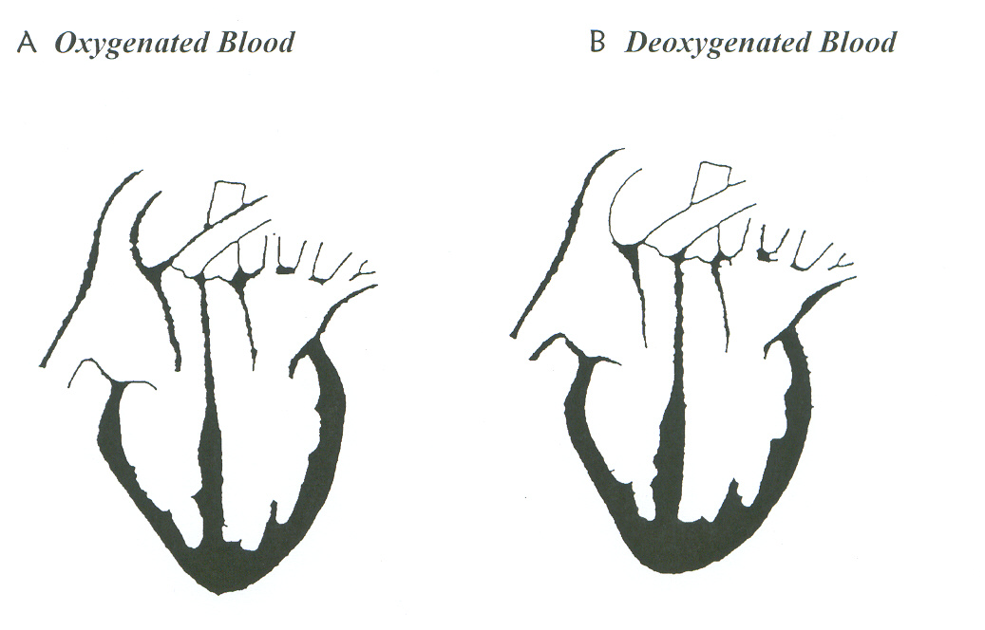
(c) Explain systolic and diastolic blood pressure in terms of what is happening in the heart.
_________________________________________________________________________________

_________________________________________________________________________________

_________________________________________________________________________________

(4)
(d) What would happen if the chordae tendonae were severed or broken?

_________________________________________________________________________________

_________________________________________________________________________________

(1)
- What are the two major functions of the lymphatic system?
(i)_________________________________________________________________________

(ii)________________________________________________________________________

(2)
- What are the names given to the following:

(i) The instrument used to measure blood pressure.

___________________________________________________________________________

(ii) The instrument used to measure the electrical impulses in the heart.

___________________________________________________________________________
(2)
QUESTION 44 REFERS TO THE DIAGRAM BELOW.

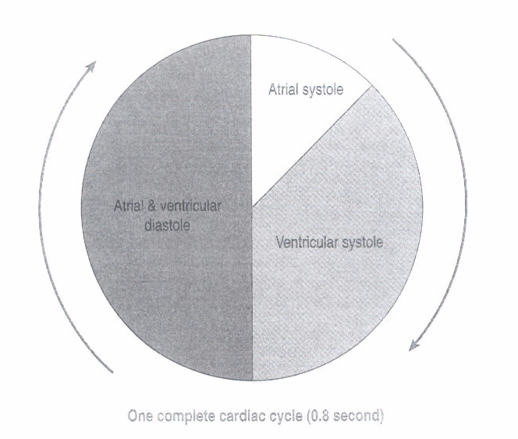

Question 44.

- What is atrial systole?__________________________________________________

- What is atrial diastole?_________________________________________________

- What is ventricular systole?_____________________________________________

- What is ventricular diastole?____________________________________________
(4)
- How long does each phase last? (Use the diagram above to calculate each)

Atrial systole _________________________________

Atrial diastole_________________________________
Ventricular systole_____________________________

Ventricular diastole____________________________ (4)

- During which of the phases above would blood pressure in the arteries be highest?

____________________________________________________________________________
(1)
- During which phase would it be lowest?

____________________________________________________________________________
(1)
- While the ventricles are in a state of diastole, why does blood pressure remain high in the arteries?

____________________________________________________________________________

____________________________________________________________________________

____________________________________________________________________________

(2)

Question 45.
FIGURE 1 – Skeleton and skeletal features of a quadruped primate, gorilla and human.
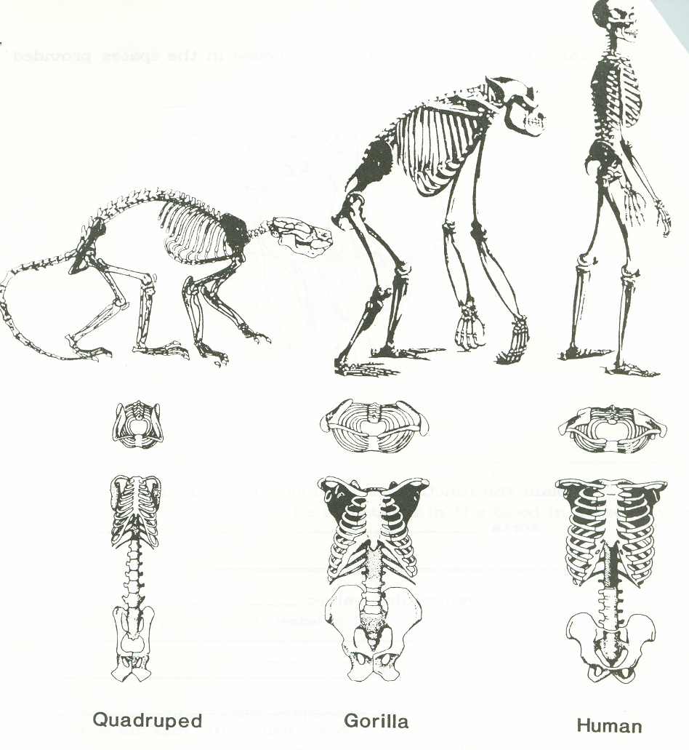
Examine the illustrations of the full skeleton and skeletal features belonging to a quadrupedal primate, gorilla and human in Figure 1 above.

(a) State ONE feature of the quadrupedal skeleton illustrated in Figure 1 which is suited for quadrupedal walking and explain how it assists this mode of locomotion.

____________________________________________________________________________________________________________________________________________________________________________________________________________________________________________________________________________________________________________________________________
(2)

(b) Describe TWO structural features evident in Figure 1 which account for the fact that the gorilla is not able to walk bipedally for extended periods of time.

(i)_______________________________________________________________________________

_________________________________________________________________________________

_________________________________________________________________________________

(ii)_______________________________________________________________________________

_________________________________________________________________________________

_________________________________________________________________________________
(4)

(c) Describe TWO structural features evident in Figure 1 which enable humans to carry out bipedalism.

(i)_______________________________________________________________________________

_________________________________________________________________________________

_________________________________________________________________________________

(ii)_______________________________________________________________________________

_________________________________________________________________________________

_________________________________________________________________________________
(4)

FIGURE 2 – PRIMATE HANDS

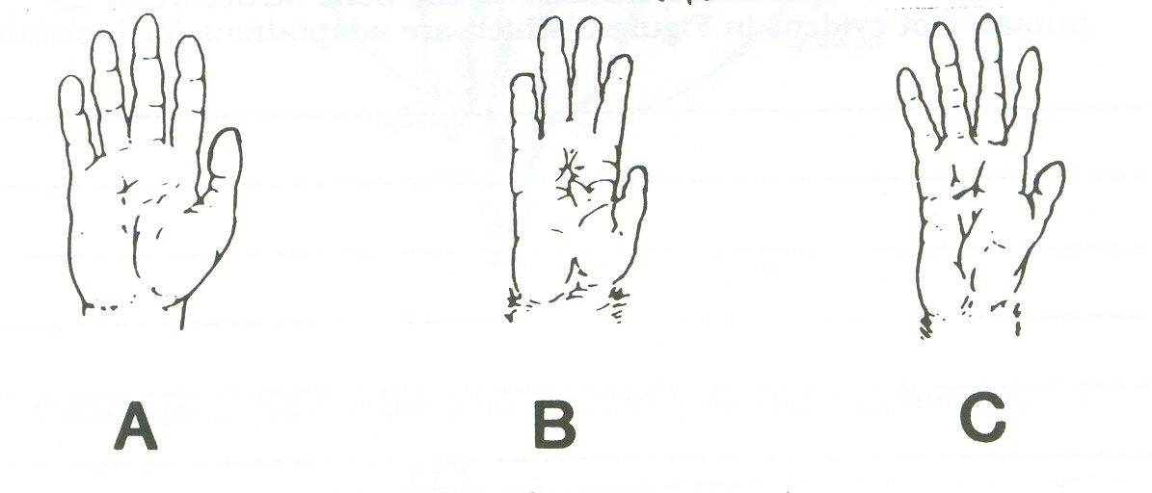

(d) Which of the hands illustrated in Figure 2 is not suited for brachiation? Explain why. Give three reasons.

_____________________________________________________________________________________________________________________________________________________________________________________________________________________________________________________________________________________________________________________________________________________________________________________________________________________
_____________________________________________________________________________________________________________________________________________________________________________________________________________________________________________________________________________________________________________________________________________________________________________________________________________________
(3)

Question 46.
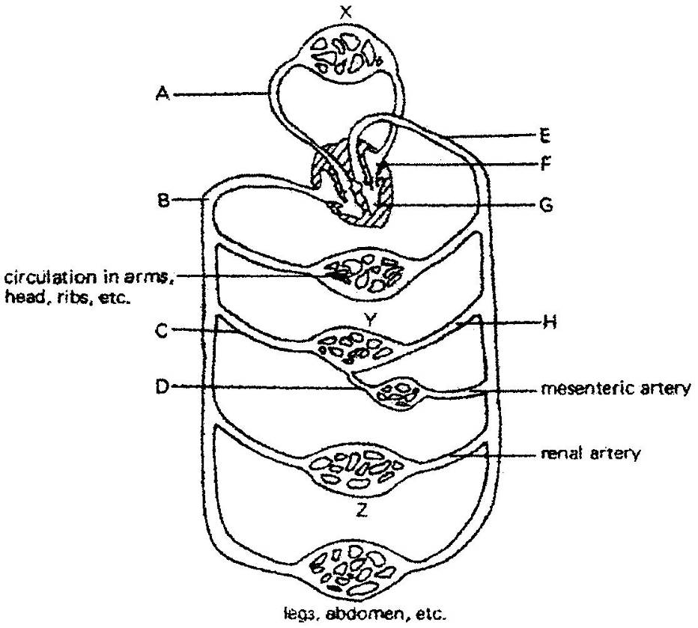

- What are the changes in blood composition in the blood when it passes through :

X ____________________________________________________________________

(1)

- What is the organ marked Z? ____________________________________________
(1)

- In space astronauts are exposed to zero gravity. Explain how blood can be transported from the heart to the rest of the body and back without the help of gravity.
_______________________________________________________________________

_______________________________________________________________________

_______________________________________________________________________
(2)

Question 47.

Below is a diagram of a small part of the circulatory system.

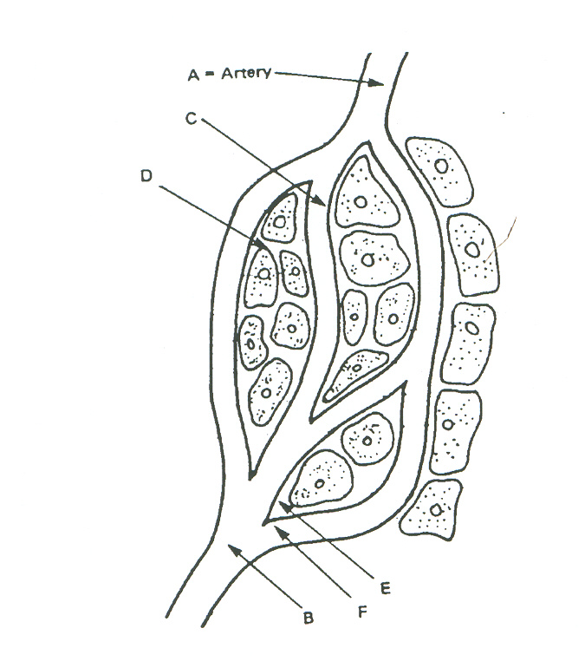
(a) Name the kind of vessel found at B. (1)

________________________________________________________________________________

(b) State one difference between the wall of the vessel at B and the vessel at A. (1)

________________________________________________________________________________

- State one difference between the blood pressure at B and A. (1)

________________________________________________________________________________

________________________________________________________________________________

(d) Name the kind of vessel found at C. (1)

________________________________________________________________________________

(e) Describe the liquid part of blood. (2)

________________________________________________________________________________

________________________________________________________________________________

(f) Name the fluid found at E. (1)

________________________________________________________________________________

(g) Name two useful substances that pass from C to D. (2)

(i)_______________________________________________________________________

(ii)_______________________________________________________________________

(h) Name one component of the blood that would not normally pass from C to D. (1)

________________________________________________________________________________

(i) Give one reason why this component would not normally pass from C to D. (1)

________________________________________________________________________________

________________________________________________________________________________

Question 48.

- Name the following tissue types and a specific location in the body where you would find each tissue. (10)

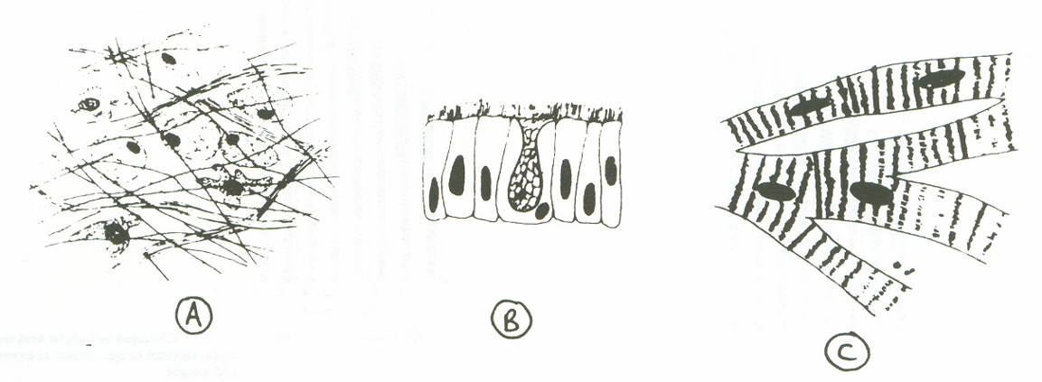
A
B
C
D
E
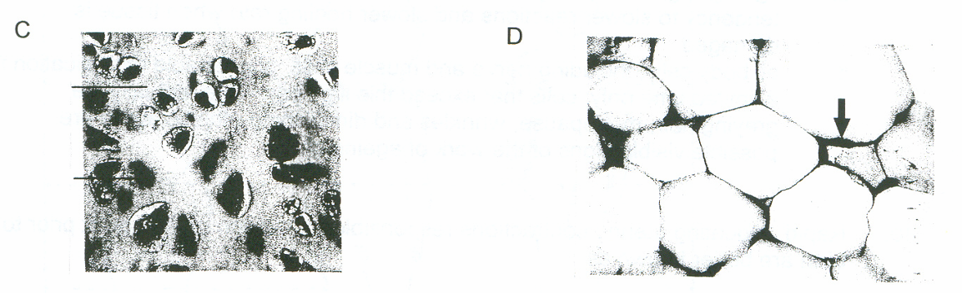

TISSUE | NAME SPECIFIC TISSUE | LOCATION FOUND IN BODY
A
B
C
D
E

(b) Explain the difference between:
(i) a benign and a malignant tumour

_________________________________________________________________________________

_________________________________________________________________________________
- a carcinoma and a sarcoma

_________________________________________________________________________________

_________________________________________________________________________________
(4)
Question 49.

The table below shows the percentage of males and females of different age groups with high blood pressure and high blood cholesterol.

Males | 25 – 29 | 30 – 34 | 35 – 39 | 40 – 44 | 45 – 49 | 50 – 54 | 55 – 59 | 60 - 64
Blood  Pressure | 5.0 | 11.4 | 15.7 | 23.0 | 24.4 | 36.8 | 39.7 | 39.4
Cholesterol | 8.1 | 16.4 | 14.3 | 22.9 | 21.3 | 25.5 | 23.5 | 22.4

Females | 25 – 29 | 30 – 34 | 35 – 39 | 40 – 44 | 45 – 49 | 50 – 54 | 55 – 59 | 60 - 64
Blood  Pressure | 2.7 | 1.9 | 8.3 | 13.8 | 27.6 | 29.9 | 37.8 | 41.2
Cholesterol | 5.1 | 6.0 | 3.7 | 10.6 | 13.6 | 29.5 | 41.1 | 48.1

(a) On the sheet of graph paper provided, draw a line graph to show the trends of high blood pressure in males and females. (5)

(b) Which group shows the highest level of cholesterol?

________________________________________________________________________________
(1)
(c) Which group shows the lowest level of blood pressure?

________________________________________________________________________________

(d) From the graph describe the relationship between high blood pressure and high blood cholesterol.
________________________________________________________________________________

________________________________________________________________________________
(2)

Question 50.

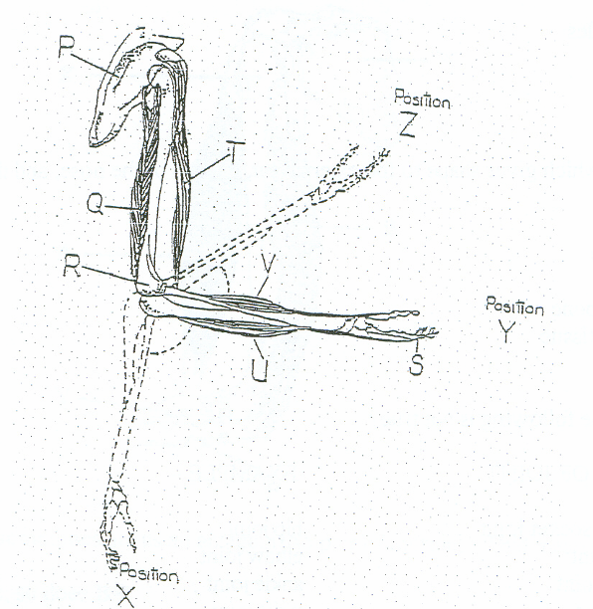

(a) Label the parts shown in the diagram above.

P _______________________________

Q _______________________________

R _______________________________

T _______________________________ (4)

- What type of joint exists between:

Bone R and the ulna ________________________________________________________

Bone P and bone R__________________________________________________________
(2)

(c) If the forearm moves from position Y to position Z, which letter in the above diagram represents the muscle which is contracting to enable movement? (1)

_______________________________________________________________________________

(d) What type of movement is occurring when the forearm moves from position Y to position X? (1)

________________________________________________________________________________
Question 51.

Draw the following diagrams to show their respective phases of Mitosis.
(3)

Metaphase

Anaphase

